Pacific Trails Resort

The following [Figures](https://jigsaw.vitalsource.com/books/9780134801346/epub/OPS/xhtml/fileP700101479300000000000000000058B.xhtml#P70010147930000000000000000008B7)shows a site map and wireframe for Pacific Trails.

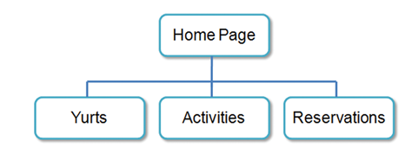

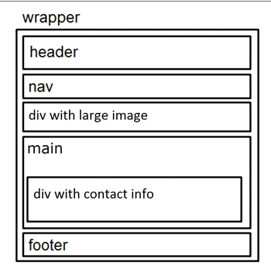

Pacific Trails Resort Home page

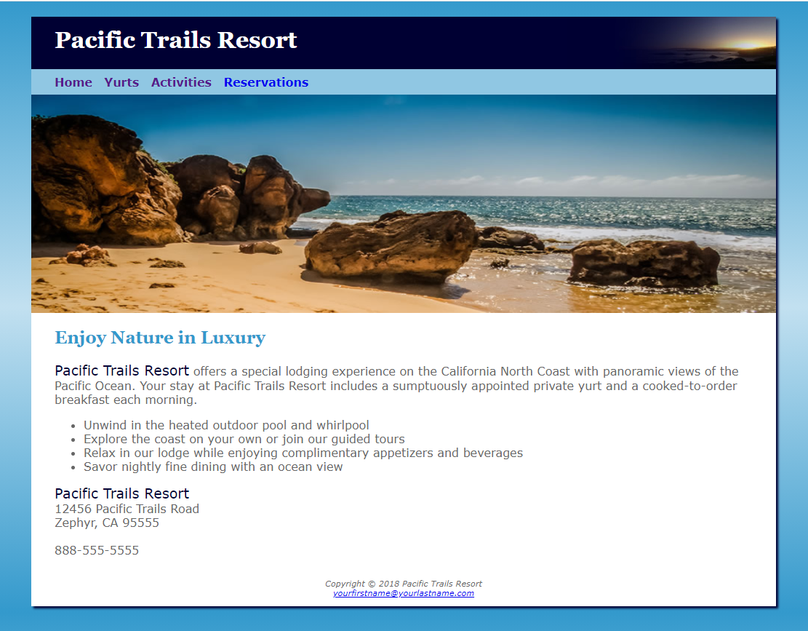

 Pacific Trails Resort Yurt Page

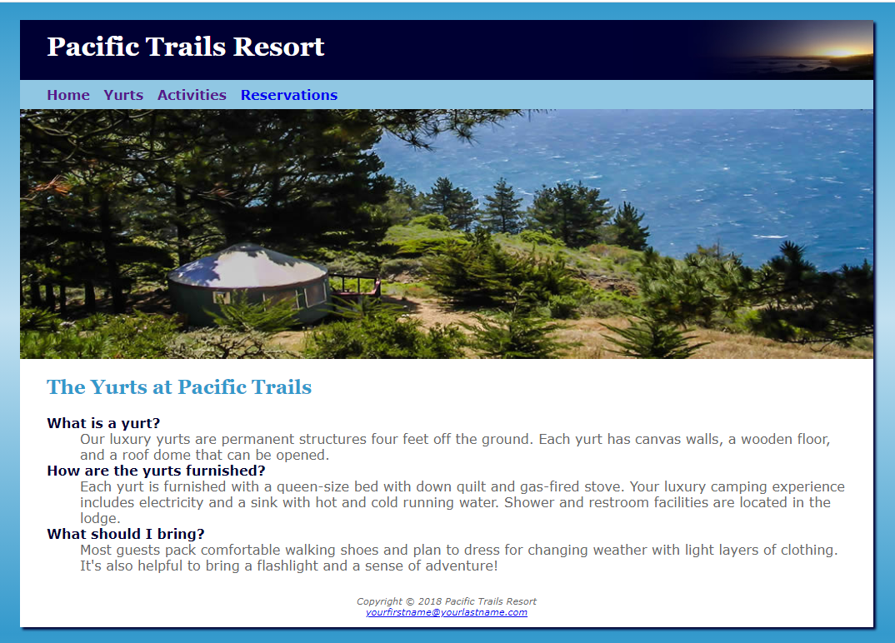

Pacific Trails Resort Activities Page

